Headteacher Update Friday 26th February 2021
Dear Parents & Carers,
How lovely to see some signs of early Spring and to know that in another week we will be welcoming all pupils back into school. The Wirral has had very high numbers of COVID cases during January and although the lockdown has reduced these significantly this month, it is important we continue to do all we can to keep numbers of positive cases low. Many of our previous protective measures will continue to be in place when children return to school, with a few additions to meet the updated government guidance.
We will be sending full details to families next week, but as an initial idea so you can plan ahead the following will be in place:
- All children will be welcomed back and return to school on Monday 8th March
- Staggered starts will be issued for each year group between 8.45am and 9.05am
- Staggered collections will be issued to year groups between 3pm and 3.30pm
- CC4C will be running from 7.30am until 6pm and returning to the usual payment plan
- Catering will be available as a hot meal or deli option for all year groups
- We will continue with our enhanced cleaning plan and ventilation in all areas
- Children will continue to work at tables of two, facing forwards and class bubbles will be kept separate to minimise potential transmission of the virus
- Children should not bring items from home into school; just their coat, water bottle and lunch if they are bringing one
- Children should continue to wear their PE kit to school on PE days to avoid changing
- Any child or member of staff presenting with symptoms will be isolated and asked to attend a COVID testing site. School staff will also continue regular non-symptom testing at home.
- Anyone with a member of their household testing positive for COVID19 or identified as a close contact of someone in a school bubble who has tested positive must self-isolate for 10 days.
Some small changes to expect:
We are risk assessing individual rooms again, along with pupil needs, staff who may be clinically vulnerable, numbers of adults and pupils in year groups. Based upon this we will be providing “overflow” areas / groupings for some year groups where it is safer and better meets pupil needs to work in smaller groupings; Y2, Y3 and Y6 will have additional space and adults to support smaller group working.

Children will have outdoor sessions planned into their timetables so they are not all in the same room all day; this will assist with us being able to thoroughly ventilate rooms and provide children with fresh air for when they are mixing socially and learning physically.

Staff will continue to work in their year group teams and will be allocated to class bubbles on set days. Pupils and staff will not mix beyond their class bubbles so we can keep household mixing to a minimum. Where specialist staff work with children, they will not work indoors with more than 2 year groups. This means that PPA cover such as sport / PSHE lessons will be for a half day and alternate each week.

Staff will wear face coverings when they are unable to maintain 2m distancing with other adults. School will support staff wearing face coverings where there is an increased risk of close contact or they feel safer doing so. If families would like children to wear face masks they are welcome to do so, but this is not an expectation and should be considered in line with the age of the child and ability to do so safely; for instance, face coverings provide more risk if young children keep touching and removing them than not wearing a covering.
Remote Learning Parent Survey Results
Thank-you to all those parents and carers who completed our online survey before half term; it has provided us with really useful feedback on how we can continue to improve as well as sharing your views on return to school. We have been so proud of the work pupils at home have been sending in and it has been amazing that over 90% of home learners have been online learning and returning work every day! Thank-you so much to all our families who have worked with school to ensure children are learning at home; we don’t underestimate the challenges this will have provided you with and we are all very grateful for all you have done at home. Summary feedback to our lockdown provision is provided below, with the detailed outcomes and comments being published on our website for further information:

Remote Learning Survey
Number of responses: 161/376 43% of school population replied to survey
Data outcome below are % of replies received, NOT of school population
Is your child accessing remote learning or emergency school provision? |  |  | How have you found this provision? |  |  | Is there anything more we can do to support you and your family? Click which one applies:
Home | School | Blended | Good | Satisfactory | Challenging | Communication | Resources inc. technology | Pastoral support | No support needed
54% | 43% | 3% | 83% | 6% | 11% | 2% | 2% | 2% | 94%

We have taken your preferences and our staff survey responses into account when planning for reopening so everyone feels as confident and comfortable with the arrangements as possible. The outcomes of the parent survey for reopening are as follows:
Return to School Parent Survey Responses – 15th February 2021
 | Stay the same – blended learning for some and small groups in school including KW / vulnerable provision | Return to school in small groups with familiar adult | Rota system alternate days | Return to whole class bubbles with protective measures | Total response per year group
FS2 | 6 | 7 | 1 | 12 | 26
Y1 | 4 | 11 | 1 | 11 | 27
Y2 | 1 | 8 | 2 | 15 | 26
Y3 | 8 | 7 | 1 | 10 | 26
Y4 | 2 | 7 | 4 | 9 | 22
Y5 | 1 | 3 | 1 | 11 | 16
Y6 | 2 | 5 | 3 | 8 | 18
Totals | 24 | 48 | 13 | 76 | 160
*42% of parents responded with the most preferred option being return to class bubbles as in Autumn term
Y6 Secondary School Allocations
Our Y6 pupils will receive their allocated secondary school next week. It will be a strange time as children may not be in school to discuss this with staff. If you are concerned about the secondary school you have been allocated, please contact the school office and Mrs Baker will arrange a time for me to call families to discuss further. We will then look forward to talking with Y6 about their secondary schools once they are all back in school and we can share the excitement of the next stage of their journey with them. We work closely with our secondary colleagues to arrange meetings with children so they can ask about their new schools and find out what Year 7 will be like. I am mindful that many Y6 pupils will not have been able to visit secondary schools due to the pandemic, so as soon as I hear about transition arrangements we will update families so you know what is in place to help your child become familiar with their secondary school. Any families wishing to appeal their secondary allocated school must do so by 31st March 2021.

Y5 Secondary Applications
I have had phone calls with a number of families who wanted to find out about 11+ entrance examinations for grammar school this week. I am expecting the timeline of secondary dates to be sent at some point in April and will then arrange either an evening meeting for families or an online meeting if we are still restricted. We are aiming for this to be during the first week in May so we can explain the process of applying for High Schools or for 11+ testing, the dates you need to apply by and how schools will be offering show rounds etc. for the current Y5 pupils to select their secondary school.
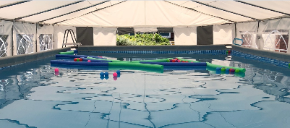
We have had a flurry of applications for F2 next year and the LA admission date is now closed. If you do know of friends who may have missed this during lockdown, please tell them to contact us as soon as possible. We have had more applications than we have places, so we don’t want anyone who is hoping for a place at Christ Church to miss out!
Swimming – exciting news!
We are in the process of negotiating a portable pool to be sited on the back playground for a short period of time during the summer term. We are concerned about the lack of access to swimming children have had over the past year so we are doing all we can to give them an opportunity to access the water with an onsite life guard and instructor.

Grounds Updates
Mr Jones and his team have been working hard throughout term time and holidays to further enhance the school. Our successful Academy Capital funding bid last year has provided us with new boilers for all areas of the school and replacement windows in the Annex building currently used by Y4. During half term new blinds were fitted and we have also had the Y5 and Y6 boys’ and girls’ toilets refurbished, making them a much more pleasant environment for the children to return to.
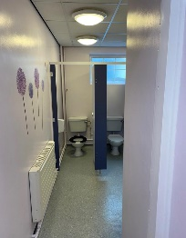
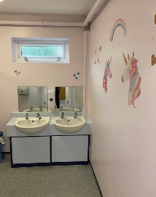
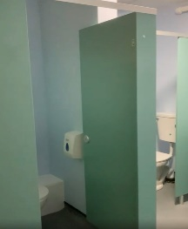
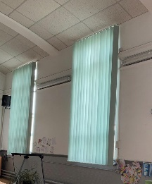
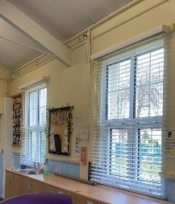
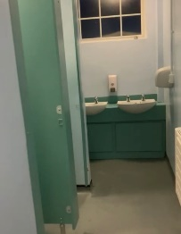
Improved toilets, replacement windows and blinds.

We will continue with remote learning next week and your teachers will be online from 9am on Monday. We are all looking forward to welcoming children back on the 8th March – further details will be with you about return arrangements for your child’s year group very soon.
Best Wishes,
Amanda Donelan
Headteacher

