

We will be busy revising lots of arithmetic, reasoning and problem-solving work to equip our children well for their education at Secondary School.

Cross-curricular topic: We will be collecting and comparing data on different African countries related to rainfall and species.

To conclude our work on the novel Letters from the Lighthouse, the children will produce, perform and edit (using I Movies) a live News Broadcast from outside Leasowe Lighthouse.

We then start our new theme of learning, which will start with children researching into different African countries and taking on the role of a travel agen, producing an informative guide to a country of their choice. On **15th May**, children are invited to come to school in the colours of an African flag (they can choose).

The text we are studying this half term is a delightful book called “Long Walk to Freedom’ By Kadir Nelson. Children will retell the story of Nelson Mandela, produce non-fiction reports, newspaper writing, and reports on animals. They will also plan and take part in debates and discussions.

**Maths**

**English**

Christ Church (Cof E) Moreton Primary School

Summer 1 2023

Y6 Curriculum Newsletter

**PSHE**

**Science:** The children will be working to identify types of habitats. They will explore animals found in habitats and how they adapt to suit these.

**Geography:** This half term, the children will compare the physical and human features of different African countries. They will extend their understanding of the history of Africa, particularly South Africa and the apartheid. They will be given the opportunity to discuss and debate such topics.

**Computing** – To learn how data is sent. To take a tour to countries within the continent using VR and AR technologies. Throughout the topic, we will explore terrain and landmarks using mapping apps.

**French** – Children will continue with their weekly language lessons, and learn how to talk about whether they (or people they know) have pets.

**Science/Topic**

Children will meet with local MP Angela Eagle and discuss issues relating to democracy, the UK Parliament and the work of an MP.

**RE & Worship**

During this half term, the children will audition for parts in the end of year production. They will undertake some rehearsals in school and also be provided with a script and song lyrics. Children are expected to learn their lines and lyrics at home. Dates and arrangements for the performance will be sent out during the final half term.

The Christian value we are embracing this half term is ‘hope’ and this will be the focus of assemblies and class worship. The main R.E. theme for our lessons is the Holy Spirit.

**PE**

PE will take place on Tuesday PM. The topic for PE sessions this half term is athletics. There will also be swimming this half term when the swimming pool returns to school at – more information to follow soon.

**Homework**

**The Arts**

**Art** - The children will explore the different arts and cultures in Africa. They will analyse different African patterns and create their own. They will investigate the work of the South African artist Esther Mahlangu.

**DT** – children will research, design and make an Andersen shelter.

**Music** –Children will explore 21st Century music and also begin to learn the songs for their end of year production.

**Nurturing achievers,**

**Maths** – Weekly maths activity.

**English –** daily reading and other weekly English homework

**Y6 Homework Project** - ‘This is Me.’ Further information will be given after SATS.

**Y6 production** *–* learning words to songs (and playscript words if they have a part in the production).

**who in Jesus’ sight are:**

**Resourceful, Reliable, Respectful and Resilient**

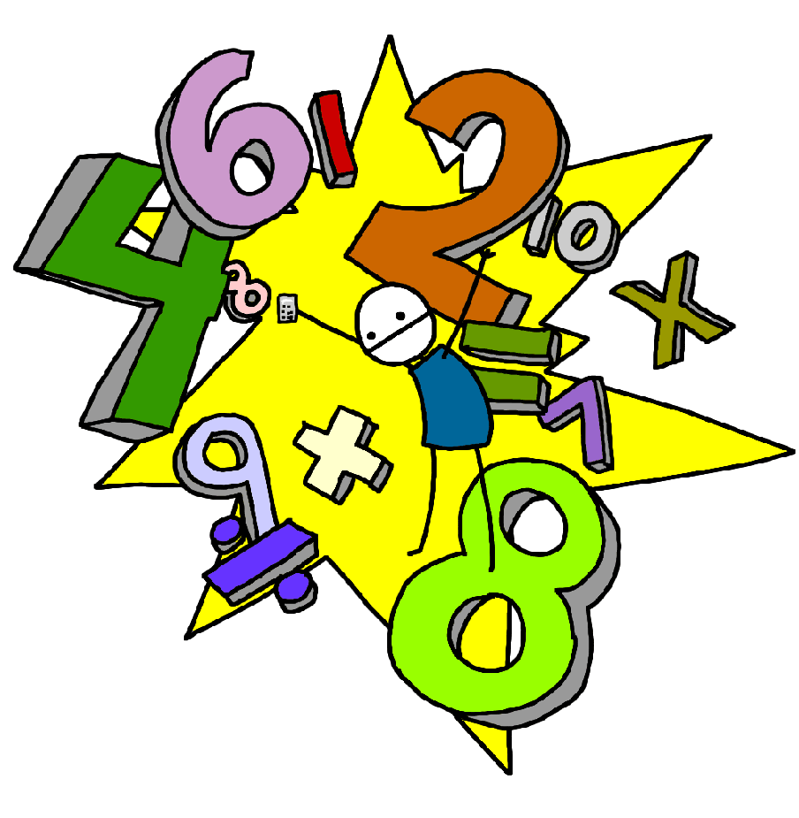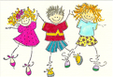[**www.christchurch-moreton.wirral.sch.uk**](http://www.christchurch-moreton.wirral.sch.uk)