Health Promotion Team
Wirral Community NHS Foundation Trust
Prenton Clinic
Prenton Village road
Wirral
CH43 0TF
Tel: 0151 514 2510

www.wchc.nhs.uk
10th January 2024

##WCTWI

Dear parent / carer

Height and weight checks for children in Foundation 2 and Year 6

Each year in England, school children in Foundation 2 and Year 6 have their height and weight checked at school as part of the National Child Measurement Programme. Height and weight measurements are used to calculate weight percentile. We collect this information because it is in the public interest to understand how many children are overweight, a healthy weight or underweight. Your child’s class will take part in this year’s programme.

The checks are carried out by trained health care providers. Children are measured fully clothed, except for their coats and shoes, in a private space away from other pupils.

Once completed, we will send you your child’s measurements together with information about healthy eating, being active and related activities available in your area

Maintaining the wellbeing of children in the NCMP

The wellbeing of children and families is very important. Measurements are conducted in a sensitive way, and away from other children. Individual results are not shared with your child or their school.

The height and weight information is shared only with you in the parent or carer feedback letter. It is your choice if you share the information with your child.

The emotional impact of the NCMP has been researched and studies show that body image, self-esteem, weight-related teasing, and restrictive eating behaviors do not change as a result of being measured or receiving feedback. If you are concerned about your child’s growth, weight, body image or eating patterns, seek further support from a school nurse or General Practitioner.

If you are happy for your child to be measured, you do not need to do anything. Your address is required to send you your child’s feedback letter. This will include your child’s measurements together with information about healthy eating, being active and related activities available in your area.

No individual measurements will be given to school staff or other children, and all information will be treated confidentially.

Withdrawing your child from the National Child Measurement Programme

If you do not want your child’s height and weight to be checked, please let us know by contacting the 0-19 health and wellbeing service on 0151 514 2510 within 10 working days. (Please note if you wish to withdraw from the programme at both Foundation 2 and year 6, a withdrawal of consent is required at both time points)

Children will not be made to take part on the day if they do not want to.

Further information about the National Child Measurement Programme can be found at https://www.nhs.uk/live-well/healthy-weight/national-child-measurement-programme

Information and fun ideas to help your kids stay healthy can be found at
https://www.nhs.uk/healthier-families/
Another way to help maintain a balanced diet and physical activity for your family is the NHS Healthy Steps email programme. Sign up for the 8-week Healthy Steps emails and you will be sent lots of low-cost easy tips, fun games, healthy swaps, and tasty recipes on a budget.

Scan the QR code or visit healthysteps.uk to sign up.
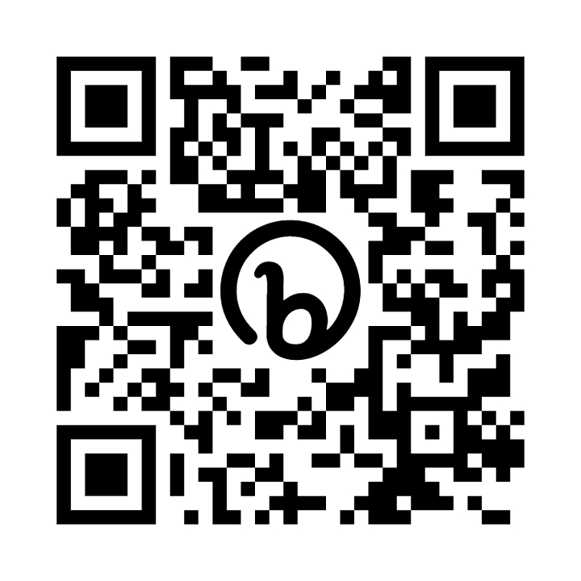

The diagram below displays what happens to your child’s data as part of the NCMP.
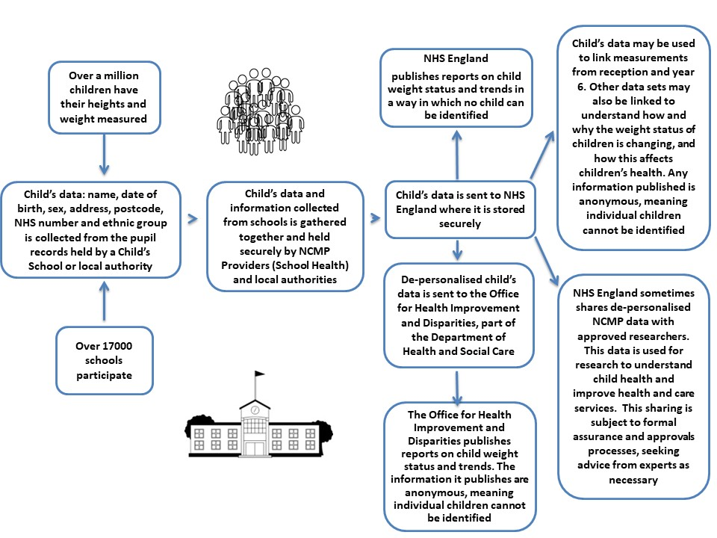
Your child’s ethnicity and address are used to help understand some of the reasons for the difference and changes in child weight across England.

All the data collected is also used for improving health, care and services through research and planning.

All this information is treated confidentially and held securely. No individual measurements will be given to school staff or other children.

How your child’s data is collected and processed as part of the National Child Measurement Programme (NCMP)

Local authorities have a legal duty to collect the NCMP data. They do this by following guidance from the Office for Health Improvement and Disparities part of the Department of Health and Social Care (DHSC). Local authorities are responsible for making decisions on how the data is collected and for making sure it is protected. Local NCMP service providers are contracted to carry this out; this might be through the school nursing team working in schools or a local healthcare provider. The team collecting the data enter it into the NCMP IT system, which is provided by NHS England. The data may also be entered into a local child health information system. Your local authority is responsible for sending the data to NHS England. NHS England and the Office for Health Improvement and Disparities are jointly responsible for the data held at a national level. Your local authority is responsible for the data held locally.

Information about how NHS England and Office for Health Improvement and Disparities collect and use information can be found at https://digital.nhs.uk/about-nhs-digital/our-work/keeping-patient-data-safe/how-we-look-after-your-health-and-care-information and https://www.gov.uk/government/organisations/department-of-health-and-social-care/about/personal-information-charter

Information about the organisations NHS England has shared information from the National Child Measurement Programme can be found at https://digital.nhs.uk/services/national-child-measurement-programme

Yours sincerely

Nicola Birkby
Team Leader, 0 - 19 Health and Wellbeing Service



