**Christ Church C of E**

**Primary School Moreton**

COVID19



**Full Opening of School**

**V10 APRIL 2022**

|  |  |  |  |
| --- | --- | --- | --- |
| Description: F:\Documents\Aug 08\CC\Current\CC cross.jpg**RISK ASSESSMENT**  **RECORDING FORM** | **Full Opening of school v10 April 2022**  **Christ Church Primary School** | Description: F:\Documents\Aug 08\CC\Current\CC cross.jpg |  |

|  |  |  |
| --- | --- | --- |
| Location or School  Address: **Christ Church Moreton Primary School** | Date assessment  Undertaken 3/01/22 reviewed 28/1/22  25/02/22 & 02/04/22 | Assessment undertaken by: Jeanne Fairbrother & Amanda Donelan HT |
| Activity or situation:  **Full Opening of school v10 April 2022** | Review date: 25/04/22 or as circumstances change | Signature: ADonelan |

|  |  |  |  |  |
| --- | --- | --- | --- | --- |
| **Background information**  From 1 April, the government's guidance on [living with COVID-19](https://www.gov.uk/government/publications/covid-19-response-living-with-covid-19) replaces the DfE's [operational guidance for schools](https://www.gov.uk/government/publications/actions-for-schools-during-the-coronavirus-outbreak).  This risk assessment has regard to all relevant guidance and legislation including, but not limited to, the following:   * The Health Protection (Notification) Regulations 2010 * The Reporting of Injuries, Diseases and Dangerous Occurrences Regulations (RIDDOR) 2013 * Public Health England (PHE) (2017) ‘Health protection in schools and other childcare facilities’ * DfE) ‘Schools COVID-19 operational guidance’ * DfE ‘Actions for early years and childcare settings during the coronavirus (COVID-19) outbreak’ * DfE (2021) ‘Face coverings in education’ * ‘Actions for out of school settings’   **Legislation and guidance**  Health and Safety at Work Act etc. 1974  Management of H&S at Work Regulations 1999  Workplace (Health, Safety and Welfare) Regulations 1992  DfE Actions for schools plus associated COVID 19 Guidance  Public Health England Guidance | | | | |
| **1) Hazard / Activity** | **2) Who can be harmed and how?** | **3) What controls exist to reduce the risk?**  ***Have you followed the hierarchy of controls (eliminate, substitute etc)?*** | **Risk Score**  **Consequence**  **X Likelihood** | **4) Any further action.**  ***This should be included in the action plan (5), below*** |
| **Failing to have adequate outbreak management/contingency plans to allow for stepping measures up and down.** | **Staff, pupils, visitors, contractors increased risk of transmission of COVID 19** | * School has a Coronavirus (COVID-19) Contingency Plan risk assessment. See **RA 029B Contingency plan** latest version (also known as an outbreak management plan) if restrictions need to be implemented due to COVID 19 variants outbreak. * School will only:   + Consider attendance restrictions as a last resort   + Keep measures to the minimum number of groups possible   + Keep measures for the shortest amount of time possible * School will take  [extra steps](https://www.gov.uk/government/publications/coronavirus-covid-19-local-restrictions-in-education-and-childcare-settings) to manage the transmission of COVID-19 and seek public health advice if the number of positive cases reaches a certain threshold. * School will follow measures recommended by the Local Authority, Director of Public Health and local protection teams (HPTs) as part of the outbreak management responsibilities. * School has updated its School Emergency Plan in line with April 1st DfE guidance [: Emergency planning and response for education, childcare, and children’s social care settings](https://assets.publishing.service.gov.uk/government/uploads/system/uploads/attachment_data/file/1065829/DfE_Emergency_Guidance.pdf) which includes public health emergencies . * School will refer to [UK Health Security Agency (UKHSA) health protection in education and childcare settings](https://www.gov.uk/government/publications/health-protection-in-schools-and-other-childcare-facilities?utm_source=01%20April%202022%20C19&utm_medium=Daily%20Email%20C19&utm_campaign=DfE%20C19)   **Cheshire & Merseyside PHE contact 0344 225 0562**   * School has assessed the reasonably foreseeable risks of transmission of COVID 19 * The risk assessment is regularly reviewed as circumstances in school and the public health advice changes. * School monitors whether the controls in place are effective. | 2X2=4 |  |
| **Communication** | **Staff, pupils, visitors, contractors increased risk of transmission of COVID 19** | * School follows latest DfE, PHE & Gov.uk, Merseyside & Cheshire PH Team and LA guidance * Latest version **RA 029A Full Opening of school** published to website & shared with unions, staff, Trust & governors. * Clear communication sent to parents and pupils with a link on the school website covering all aspects of how school will function. * Regular staff briefings held to cover any changes to arrangements. * School has shared with all staff the measures in place and involved staff & the governing body in that process. * A record is kept of all visitors and contractors that come to the school site. * Visitors with access to school are asked to declare that they have no COVD symptoms before admission | 2X2=4 |  |
| **Wellbeing - staff & pupils** | **Staff & pupils exposed to mental health issues due to COVID 19** | * Staff are vigilant in discerning pupil mental health and report any concerns to the child and family mentor. * The school provides opportunities for pupils to talk about their mental health and experiences during the pandemic and there is a system to identify and then provide relevant support as needed. * Pupils have access to pastoral support and activities through PSHE sessions, outdoor learning and forest school with opportunities to renew and develop friendships. * Feedback is taken for parents and pupils to enable staff to act on any concerns pupils and parents may have. * Feedback is requested from staff to assess how they feel about being on the school site and enable the SLT to act on any concerns staff and volunteers may have. | 3X2=6 |  |
| **Face coverings** | **Staff, pupils, visitors, contractors increased risk of transmission of COVID 19** | * Face coverings are no longer advised for pupils, staff and visitors in classrooms or communal areas * Staff and pupils should follow wider advice on face coverings outside of school, including on transport to and from school. * School may be advised by a director of public health that face coverings should temporarily be worn in communal areas or classrooms (by pupils, staff and visitors, unless exempt). School has contingency plans that cover this possibility. * Staff and adult visitors will be supported if they choose to wear a face covering when moving around the premises, outside of classrooms, such as in corridors and communal areas. * In order to be most effective, a face covering should fit securely around the face to cover the nose and mouth and be made of a breathable material capable of filtering airborne particles. * Face coverings can be disposed of in normal waste | 2X2=4 |  |
| **School fails to ensure good hygiene & cleaning standards in school to reduce risk of transmission.** | **Staff, pupils, visitors, contractors increased risk of transmission of COVID 19** | **Hand hygiene** -   * School will continue to ensure that staff & pupils maintain high standards of hand hygiene. * Suitable facilities are provided for individuals to wash/sanitise their hands regularly both indoors and outside   **Cleaning**   * School will maintain appropriate cleaning regimes, using standard products such as detergents with a focus on frequently touched areas. | 2X2=4 |  |
| **Events in School** | **Staff, pupils, visitors, contractors increased risk of transmission of COVID 19** | * **School staff complete risk assessments for individual events, seeking advice from SLT on current case management** * Assemblies will be in keystages with an aisle between classes in a year group, doors and windows open and all forward facing. Those delivering will be distanced from F2F contact * Staggered starts are no longer in place, but school continues to use the 3 entry points to separate volume accessing the site * lunch and breaks will be limited to 2 year groups in the canteen / hall at any given time, with tables wiped down in between services and rooms well ventilated. * 2 year groups may mix on playgrounds * Staff meetings will take place in a larger, well-ventilated spaces – hall for whole staff or double classrooms for teaching teams * Staffrooms must remain well ventilated using windows and door if C02 monitor indicates air needs circulating more * Meetings will be in person in well ventilated spaces – classrooms and offices for small groups and double classrooms and hall for larger groups (over 20 persons) * All rooms to be well ventilated and those classrooms without direct external access will have HEPA filter units * School has **outbreak management plans** in place to reintroduce temporary measures if it becomes necessary due to local outbreaks or increases in cases at the instruction of PHE Teams. See **RA 029B Contingency Plan** | 2x2=4 |  |
| **Ventilation - failure to ensure all occupied spaces are well ventilated.** | **Staff, pupils, visitors, contractors increased risk of transmission of COVID 19** | * When school is in operation, it is well ventilated with comfortable teaching environments. * Poorly ventilated spaces have been identified and HEPA filter units or Co2 monitors have been placed spaces that are smaller and without external doors. * When holding events where visitors are on site e.g. school assemblies, ventilation is increased School opens external windows, doors & internal doors (where safe to do so) to increase ventilation. * During colder weather, the need for increased ventilation while maintaining a comfortable temperature is balanced; arranging seating away from draughts * In cooler weather to reduce thermal discomfort caused by increased ventilation, pupils can wear additional, suitable indoor items of clothing in addition to their usual uniform.. (See HSE Balancing ventilation with keeping people warm) * Purging or airing rooms as frequently as possible to improve ventilation usually when the room is unoccupied. It is advised that rooms are purged at 3 points during the day; morning break, lunchtime and midway through the afternoon. Should there be positive cases the regularity of purging rooms is increased to hourly. * Outside space will be used, where practical. **HEPA filter units have been installed** where a space is poorly ventilated following manufacturers’ instructions. **Co2 monitors** are usedto help identify others areas. School will test areas several times and the site manager will review each monitor weekly. Staff with monitors in their rooms should check the recordings and purge the room if C02 levels rise to the red area * Monitors are recalibrated according to manufacturer’s instructions. * **Hepa UVc filters have been installed in classrooms without direct access to the outdoors and will be inspected by the site manager and filters will be cleaned monthly**   *The Health and Safety Executive* [*guidance on air conditioning and ventilation during the coronavirus outbreak*](https://www.hse.gov.uk/coronavirus/equipment-and-machinery/air-conditioning-and-ventilation/index.htm)  *&* [*CIBSE COVID*](https://www.cibse.org/coronavirus-covid-19) *advice provides more information.* | 3X2=6 |  |
| **Close contacts** | **Staff, pupils, visitors, contractors increased risk of transmission of COVID 19** | * From 24 February, routine contact tracing will end. Contacts will no longer be required to self-isolate or advised to take daily tests. * Families and staff should notify school of cases within their household so that contacts may be monitored * Local health teams continue to use contact tracing and provide context-specific advice where they assess this to be necessary as part of their role in managing infectious * diseases. * Staff or pupils who are close contacts should:   + avoid contact with anyone who is at [higher risk of becoming severely unwell](https://www.gov.uk/government/publications/covid-19-people-with-covid-19-and-their-contacts/covid-19-people-with-covid-19-and-their-contacts#higherrisk) if they are infected with COVID-19, especially [those whose immune system means they are at higher risk of serious illness from COVID-19, despite vaccination](https://www.gov.uk/government/publications/covid-19-guidance-for-people-whose-immune-system-means-they-are-at-higher-risk/covid-19-guidance-for-people-whose-immune-system-means-they-are-at-higher-risk)   + limit close contact with other people especially in crowded, enclosed or poorly ventilated spaces   + wear a well-fitting [face covering](https://www.gov.uk/government/publications/face-coverings-when-to-wear-one-and-how-to-make-your-own) made with multiple layers or a surgical face mask if you do need to have close contact with other people, or you are in a crowded place   + wash hands frequently with soap and water or use hand sanitiser | 2X2=4 |  |
| **Positive case unaware of new guidance** | **Staff, pupils, visitors, contractors increased risk of transmission of COVID 19** | * Those with a positive test result will be advised to try to stay at home and avoid contact with other people:   + Staff for 5 days   + Pupils for 3 days * Both pupils and staff should try to stay home and avoid contact with others if they have symptoms of a respiratory infection and a high temperature or if they feel unwell (returning to school when they feel well enough, and no longer have a high temperature) | **3X2=6** |  |
| **Asymptomatic testing** | **Staff, pupils, visitors, contractors increased risk of transmission of COVID 19** | * Staff and students in all education and childcare settings are no longer required to carry out twice weekly asymptomatic testing. * Free testing no longer available for schools and no longer advised in specialist settings * If there's an outbreak in school, local directors of public health might advise testing for staff, and for pupils of secondary age and above, for a period of time * Spare tests should be stored securely and only used if advised by local health protection team, local authority or director of public health or in the instance that the HT is managing an increased number of staff cases or vulnerable staff and there is a risk to operational management | 3X2=6 |  |
| [**People at higher risk of becoming seriously unwell from a respiratory infection, including COVID-19**](https://www.gov.uk/guidance/people-with-symptoms-of-a-respiratory-infection-including-covid-19?utm_medium=email&utm_campaign=govuk-notifications-topic&utm_source=3a615d8c-ae10-4b5b-b155-6d92418a2b4a&utm_content=immediately#people-at-higher-risk-of-becoming-seriously-unwell-from-a-respiratory-infection-including-covid-19)   * older people * pregnant * unvaccinated * people of any age [whose immune system means they are at higher risk of serious illness](https://www.gov.uk/government/publications/covid-19-guidance-for-people-whose-immune-system-means-they-are-at-higher-risk) * people of any age with [certain long-term conditions](https://www.nhs.uk/conditions/coronavirus-covid-19/people-at-higher-risk/who-is-at-high-risk-from-coronavirus/) | **Staff, pupils, visitors, contractors increased risk of transmission of COVID 19** | * School is aware that certain staff and pupils may be at higher risk becoming seriously unwell from respiratory infections. * People in this category are advised to follow [Living safely with respiratory infections including Covid 19](https://www.gov.uk/guidance/living-safely-with-respiratory-infections-including-covid-19) * School will discuss any concerns with employees and parents/carers and this may form the basis of a personal risk assessment. * Employees who have received personal advice from their specialist or clinician on additional precautions to take should continue to follow that advice and advise school. | 3X2=6 |  |
| **Contractors** | **Staff, pupils, visitors, contractors increased risk of transmission of COVID 19** | * School has made all key contractors aware of the school’s control measures and ways of working at initial pre-start meeting and monthly review meetings. Any intermittent changes will be updated by site manager direct with contractors. * Scholl requests risk assessments from contractors working in school and supervises work on site | 2x2=4 |  |

|  |  |
| --- | --- |
| **Risk Rating** | **Action Required** |
| **20 - 25** | **Unacceptable** – stop activity and make immediate improvements |
| **10 - 16** | **Urgent action** – take immediate action and stop activity, if necessary, maintain existing controls vigorously |
| **5 - 9** | **Action –** Improve within specific timescales |
| **3 - 4** | **Monitor** – but look to improve at review or if there is a significant change |
| **1 - 2** | **Acceptable** – no further action but ensure controls are maintained & reviewed |

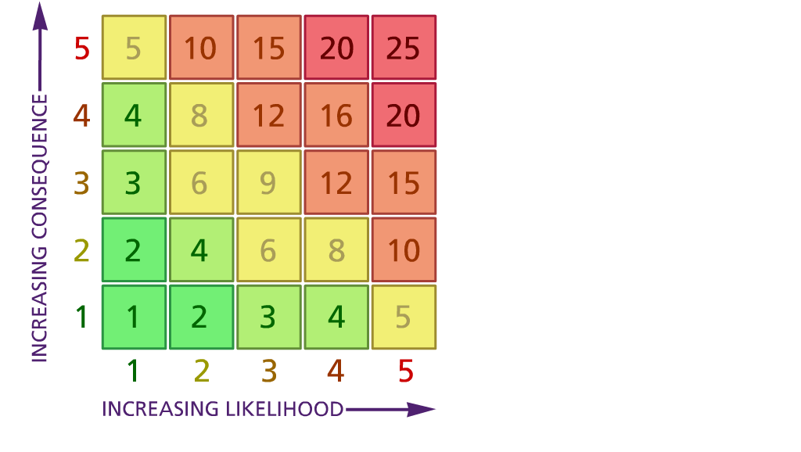

**Likelihood: Consequence**:

(1) List hazards ***something with the potential to cause harm*** here

(2) List groups of people who are especially at risk from the significant hazards which you have identified

1. List existing controls here or note where the information may be found. Then try to quantify the level of risk ***the likelihood of harm arising*** that remains when the existing controls are in place based on the number of persons affected, how often they are exposed to the hazard and the severity of any consequence*.* Use this column to list the controls that you might take and develop all or some of that list into a workable action plan. Have regard for the level of risk, the cost of any action and the benefit you expect to gain. Agree the action plan with your team leader and make a note of it overleaf. If it is agreed that no further action is to be taken this too should be noted.

5 – Very likely 5 – Catastrophic

4 – Likely 4 – Major

3 – Fairly likely 3 – Moderate

2 – Unlikely 2 – Minor

1 – Very unlikely 1 – Insignificant

(5) **ACTION PLAN**

|  |  |  |  |
| --- | --- | --- | --- |
|  | **5. Action plan** | **Responsible** | **Completed** |
| 1 |  |  |  |
| 2 |  |  |  |
|  | **Action plan agreed by Amanda Donelan 02/04/22** |  |  |