Dear Parents and Carers,
We have an exciting day planned for the children next week!

On Friday 20th May we have our CCPA Film night after school. We are inviting children to wear their pyjamas to school for the day in exchange for dried / tinned produce ( see attachment ) which will be donated to Charles Thompson Mission who are dedicated to providing food, clothes and care to those across the Wirral that are living in poverty. This is at the request of one of our Year 5 pupils who has asked if we can show kindness to those who may be struggling with increased living costs.
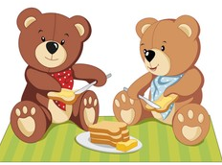
Children can wear their PJs all day on Friday 20th and bring a teddy bear into school for a lunchtime Teddy Bears Picnic supported by our super catering team. Older pupils who may not want to bring teddy bears can have their picnic lunch outside if the weather is warm enough and enjoy a chilled ‘picnic in the park’ style lunchtime.
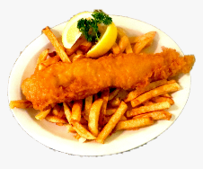
We know children enjoy the ‘Friday Fish’ lunch so we will move this to Thursday 19th next week so they don’t miss their favourite!

To order fish and chips for Thursday 19th or a picnic lunch for Friday 20th please book on parent pay as usual. Infants and FSM pupils will be provided with a lunch and should order with their teachers during registration as usual. If your child pays for their lunch, please book on parent pay.

Don’t forget children to wear PJs on Friday and donate whatever you feel able to for Charles Thompson Mission.

If you have any further questions, please contact the school office.
Thank you in advance for your support!

Christ Church

