Wellbeing Support during Covid-19

We hope you are all safe and well during this challenging time.
To help you and your family maintain good mental health and wellbeing, here are some links to a selection of sites providing information and resources to support you.

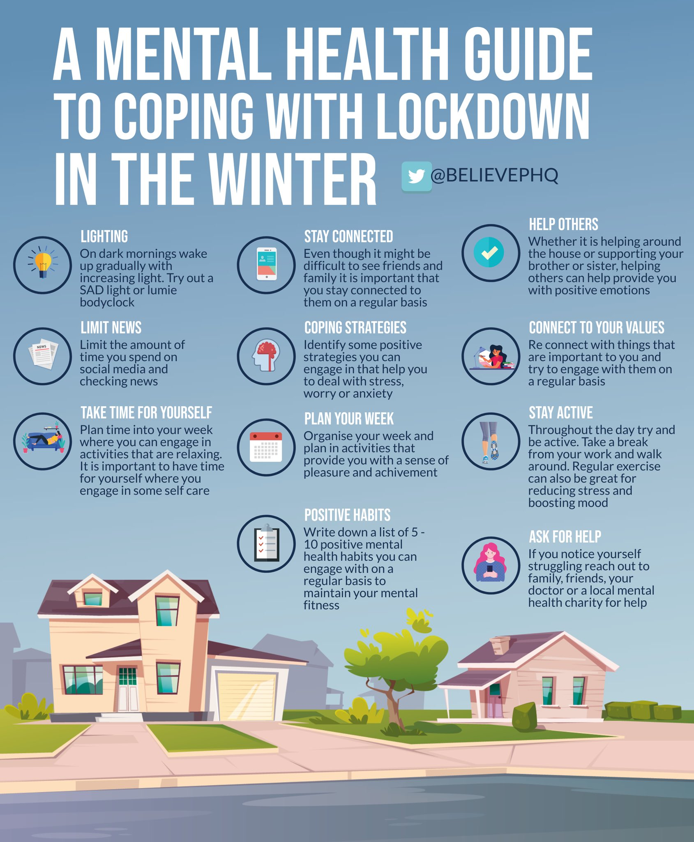
Helpful resources for talking to children about Coronavirus
https://www.elsa-support.co.uk/wp-content/uploads/2020/03/Story-about-Coronavirus.pdf
https://brogdalecic.co.uk/2020/04/01/covibook-supporting-and-reassuring-children-around-the-world/
https://www.bbc.co.uk/newsround#more-stories-4
https://nursedottybooks.files.wordpress.com/2020/03/dave-the-dog-coronavirus-1-1.pdf

Charities supporting your family’s mental health
https://youngminds.org.uk/blog/talking-to-your-child-about-coronavirus/#ten-tips-from-our-parents-helpline
https://www.place2be.org.uk/coronavirus
https://www.mind.org.uk/information-support/coronavirus/coronavirus-and-your-wellbeing/

Support information from Wirral Educational Psychology team
https://localofferwirral.org/looking-after-yourself-looking-after-your-children/

Resources for support
https://mentallyhealthyschools.org.uk/resources/reflecting-on-lockdown-activity/
https://mentallyhealthyschools.org.uk/resources/supporting-children-with-anxiety-tools-for-parents/
https://www.familylives.org.uk/advice/your-family/family-life/coping-practically-and-emotionally-during-the-covid-19-outbreak/

Have some fun!

https://www.woodlandtrust.org.uk/blog/2021/01/lockdown-activities-kids-winter/
https://www.nhs.uk/change4life/activities
https://www.annafreud.org/on-my-mind/self-care/

